CS09102: CCNP Routing
Tutorial Week 2: IP Classless Addressing (Correction)
Author: Dr Imed Romdhani

Exercise 1: VLSM

Objective
Create an addressing scheme using variable length subnet masking (VLSM).
Scenario for all exercises
The assignment is the Class C address 192.168.10.0 and it must support the network shown in the diagram. The use of IP unnumbered or NAT is not permitted on this network. Create an addressing scheme that meets the requirements shown in the diagram.

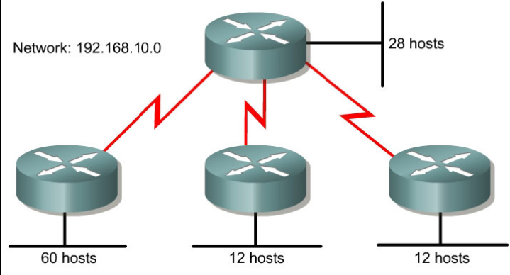

First Step:

The largest Ethernet requires 6 bits for the host part so that we can assign enough addresses for 60 machines (2⁶-2 = 62 > 60)

The default subnet mask is 255.255.255.0 (/24). This means that it remains 8 bits for the host part that can be used to create many other subnets. Therefore the length of this subnet (/24) can be expended.

If we expend it by 2 bits, we obtain 4 other subnets with equal size of 62 machines each

192.168. 0 0 0 0 1 0 1 0 x x x x x x x x

192.168. 0 0 0 0 1 0 1 0 0 0 x x x x x x : 192.168.10.0/26

192.168. 0 0 0 0 1 0 1 0 0 1 x x x x x x : 192.168.10.64/26

192.168. 0 0 0 0 1 0 1 0 1 0 x x x x x x : 192.168.10.128/26

192.168. 0 0 0 0 1 0 1 0 1 1 x x x x x x : 192.168.10.192/26

192.168. 0 0 0 0 1 0 1 0 0 0 x x x x x x : 192.168.10.0/26

0 0 0 0 0 0 192.168.10.0 The network @
0 0 0 0 0 1 192.168.10.1 The first host address
0 0 0 0 1 0 192.168.10.2 The second host address
0 0 0 0 1 1

1 1 1 1 1 0 192.168.10.62
1 1 1 1 1 1 196.168.10.63 The broadcast address

192.168. 0 0 0 0 1 0 1 0 0 1 x x x x x x : 192.168.10.64/26
0 0 0 0 0 0 192.168.10.64 The network @
0 0 0 0 0 1 192.168.10.65 The first host address
0 0 0 0 1 0 192.168.10.67 The second host address
0 0 0 0 1 1

1 1 1 1 1 0 192.168.10.126
1 1 1 1 1 1 196.168.10.127 The broadcast address

We do the same for the 192.168.10.128/26 and we obtain the network address and the valid IP addresses for that network (subnet)

192.168. 0 0 0 0 1 0 1 0 1 0 x x x x x x : 192.168.10.128/26

192.168. 0 0 0 0 1 0 1 0 1 1 x x x x x x : 192.168.10.192/26

Second Step

We choose one of the subnet mask obtained in Step one and we assign it to the largest Ethernet with 60 machines. For example we take 192.168.10.0/26. Therefore, it remains 3 subnets that are unused 192.168.10.64/26; 192.168.10.128/26; and 192.168.10.192/26. As these subnets could address 62 machines, and the second largest Ethernet contains only 28 machines, it will be unwise to use one of these subnet masks (subnet) to assign 62 valid addresses just for 28 hosts.

So, we take one of these available subnets, and we split it into two sub-subnets of 30 machines each by expending the mask (/26) to (/27)

192.168. 0 0 0 0 1 0 1 0 0 1 x x x x x x : 192.168.10.64/26
192.168. 0 0 0 0 1 0 1 0 0 1 0 x x x x x : 192.168.10.64/27 (contains 30 machines)
192.168. 0 0 0 0 1 0 1 0 0 1 1 x x x x x : 192.168.10.96/27 (conatins 30 machines)

192.168. 0 0 0 0 1 0 1 0 0 1 x x x x x x : 192.168.10.64/27
192.168. 0 0 0 0 1 0 1 0 0 1 0 0 0 0 0 0 : 192.168.10.64 The network @
0 0 0 0 0 1 : 192.168.10.65 The first host @
0 0 0 1 0 : 192.168.10.65 The second host @ …
1 1 1 1 0 : 192.168.10.94 The first host @
1 1 1 1 1 : 192.168.10.95 The broadcast @

192.168. 0 0 0 0 1 0 1 0 0 1 1 x x x x x : 192.168.10.96/27
0 0 0 0 0 : 192.168.10.96 The network @
1 0 0 0 0 1 : 192.168.10.97 The first host @
0 0 0 1 0 : 192.168.10.98 The second host @ …
1 1 1 1 0 : 192.168.10.126 The first host @
1 1 1 1 1 : 192.168.10.127 The broadcast @

Therefore we can attribute one of these subnets (example: 192.168.10.64/27) to the second

The remaining one (192.168.10.96/27) could be re-subnetted again

Step 3

It remains two Ethernet subnets with 12 machines each, however we have an available subnet (192.168.10.96/27) with 30 machines. Therefore, we can split this subnet into two additional sub-subnets with 14 machines each. To do so, we expend the mask 192.168.10.96/27 by one additional bit (192.168.10.96/28) and we obtain two sub-subnets as follow:

192.168. 0 0 0 0 1 0 1 0 0 1 1 x x x x x : 192.168.10.96/27
192.168. 0 0 0 0 1 0 1 0 0 1 1 0 x x x x : 192.168.10.96/28 (contains 14 machines)
192.168. 0 0 0 0 1 0 1 0 0 1 1 1 x x x x : 192.168.10.112/28 (contains 14 machines)

Step 4

We use (192.168.10.96/28) and (192.168.10.112/28) to assign addresses for the two remaining Ethernets of 12 machines each.
As we have extensively used the original mask 192.168.10.64/26 (we expended twice) and we cannot no more expend it again, we come back to the first step and look which is the remaining unused subents and we re-subnet them following the same procedure to fulfil our requirements.
The two remaining and unused subnets are 192.168.10.128/26 and 192.168.10.192/26. As we have 3 Serial links that require just two addresses for the routers’ interfaces. We choose one of these subnets and we re-subnet it again by varying the length of the subnet mask.
So, if we expend any subnet mask to /30, we obtain 192.168.10.128/30 and 192.168.10.192/30 that could satisfy our needs as each subnet could address 2 machines.

